

**Use Case Diagrams**

**By**

**EBOWOICHO EMMANUEL ONAH**

**500252011**

The Use Case Diagram Screen Shot

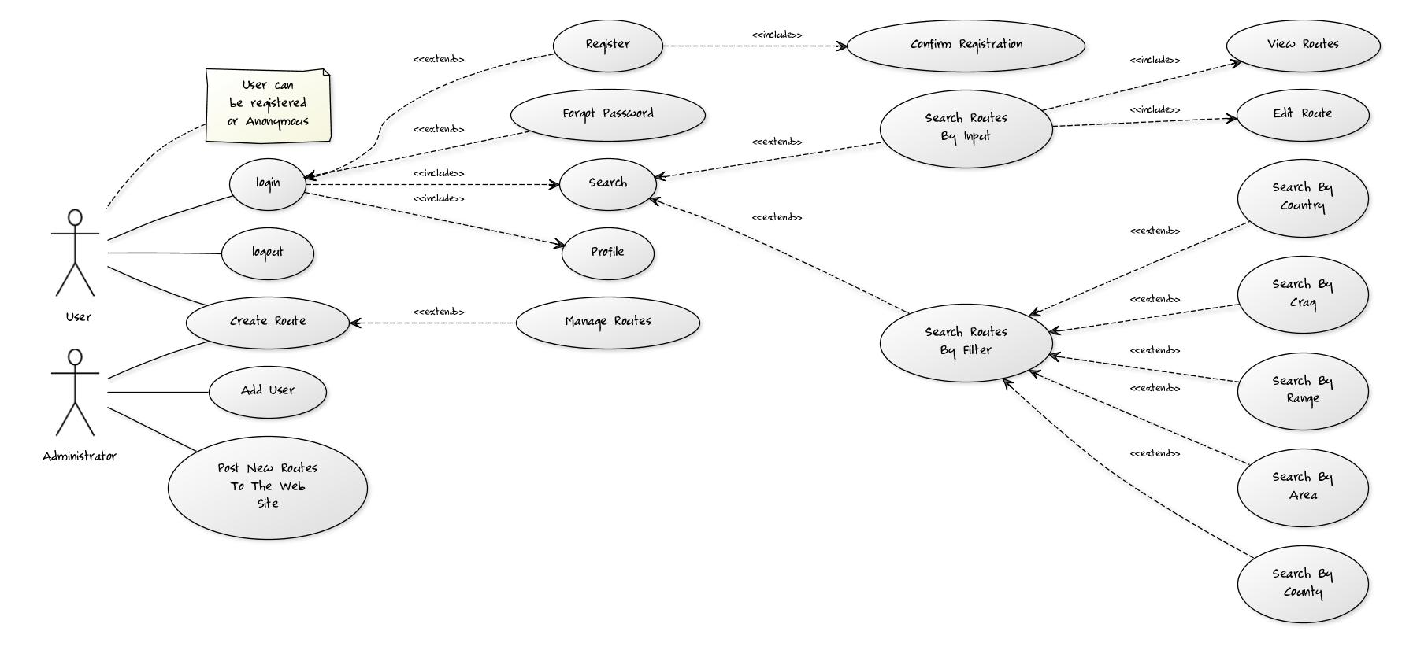

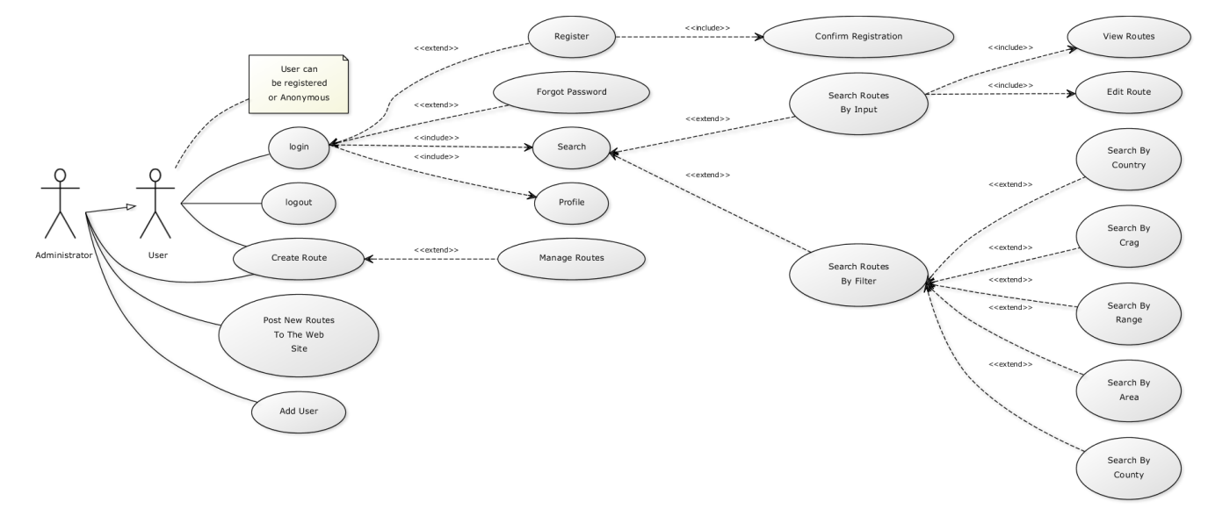

The Source Code of the Diagram

[User]-(login),(login)>(Profile),(login)>(Search),(Search)<(Search Routes By Filter),(Search Routes By Filter)<(Search By Country),(Search Routes By Filter)<(Search By County),(Search Routes By Filter)<(Search By Area),(Search Routes By Filter)<(Search By Range),(Search Routes By Filter)<(Search By Crag),(Search)<(Search Routes By Input),(Search Routes By Input)>(View Routes),(Search Routes By Input)>(Edit Route),(login)<(Forgot Password),(login)<(Register),(Register)>(Confirm Registration),[Administrator]-(Create Route),(Create Route)<(Manage Routes),[User]-(Create Route),[Administrator]-(Post New Routes To The Web Site),[Administrator]-(Add User),[User]-(logout),[User]-(note: User can be registered or Anonymous{bg:beige})

Source code for second image

[Administrator]^[User],[User]-(login),(login)>(Profile),(login)>(Search),(Search)<(Search Routes By Filter),(Search Routes By Filter)<(Search By Country),(Search Routes By Filter)<(Search By County),(Search Routes By Filter)<(Search By Area),(Search Routes By Filter)<(Search By Range),(Search Routes By Filter)<(Search By Crag),(Search)<(Search Routes By Input),(Search Routes By Input)>(View Routes),(Search Routes By Input)>(Edit Route),(login)<(Forgot Password),(login)<(Register),(Register)>(Confirm Registration),[Administrator]-(Create Route),(Create Route)<(Manage Routes),[User]-(Create Route),[Administrator]-(Post New Routes To The Web Site),[Administrator]-(Add User),[User]-(logout),[User]-(note: User can be registered or Anonymous{bg:beige})

Syntax Overview

|  |  |
| --- | --- |
| Use Case | **(Login)** |
| Actor | **[User]** |
| <<Extend>> | **(Login)<(Forgot Password)** |
| <<Include>> | **(Register)>(Confirm Registration)** |
| Notes | **[Admin]^[User],[Admin]-(note: Most privileged user)** |

Search Routes by Input Use case Described:

1. User comes into the site

2. User is in search of a specific route

3. The User inputs his route into the search bar and if the route is available the user clicks on the route and has the choice of either to view or to edit the route or both.